

**TITLE OF PROJECT REPORT**

**MOVIREC**

### **A PROJECT REPORT**

***Submitted by***

### **NAME OF THE CANDIDATE(S):**

1. Shivangi Srivastava - 2115000958
2. Deepti Garg - 2115000329
3. Prashant Bhadoria - 2115000744
4. Priyanshu Kumar Tiwari – 2115000783

***in partial fulfillment for the award of the degree of***

**BACHELOR OF TECHNOLOGY**

**I****N**

COMPUTER SCIENCE OF ENGINEERING

GLA University, Mathura

##### DECEMBER 2023

##### **BONAFIDE CERTIFICATE**

Certified that this project report **MOVIREC** is the bonafide work of **Shivangi Srivastava, Deepti Garg, Priyanshu Kumar Tiwari, Prashant Bhadoria** who carried out the project work under my/our supervision.

|  |  |
| --- | --- |
|  |  |
| **SIGNATURE**  Dr. Rohit Agarwal  **HEAD OF THE DEPARTMENT**  **Computer Engineering and Applications** | **SIGNATURE**  **Mr. Sandeep Kumar Chokker**  **SUPERVISOR**  Training and Development |

Submitted for the project viva-voce examination held on 02/12/2023

**INTERNAL EXAMINER EXTERNAL EXAMINER**

#### 

#### **TABLE OF CONTENTS**

List of Figures..................................................................................................... i

Graphical Abstract............................................................................................................ ii

##### **Graphical Abstract .................................................................................... 4**

##### **Abbrevations ............................................................................................. 5**

##### **Symbols .................................................................................................... 6**

##### **Chapter 1. ................................................................................................. 7**

**Chapter2. ………………………………………………………….13**

**Chapter 3..........................................................................................23**

**Chapter 4. ………………………….………………………………37**

**Chapter 5. …………………………………………………………39**

**References.........................................................................................41**

# **List of Figures**

**Figure 3.1 ……………………………………………………………36**

# 

# **GRAPHICAL ABSTRACT**

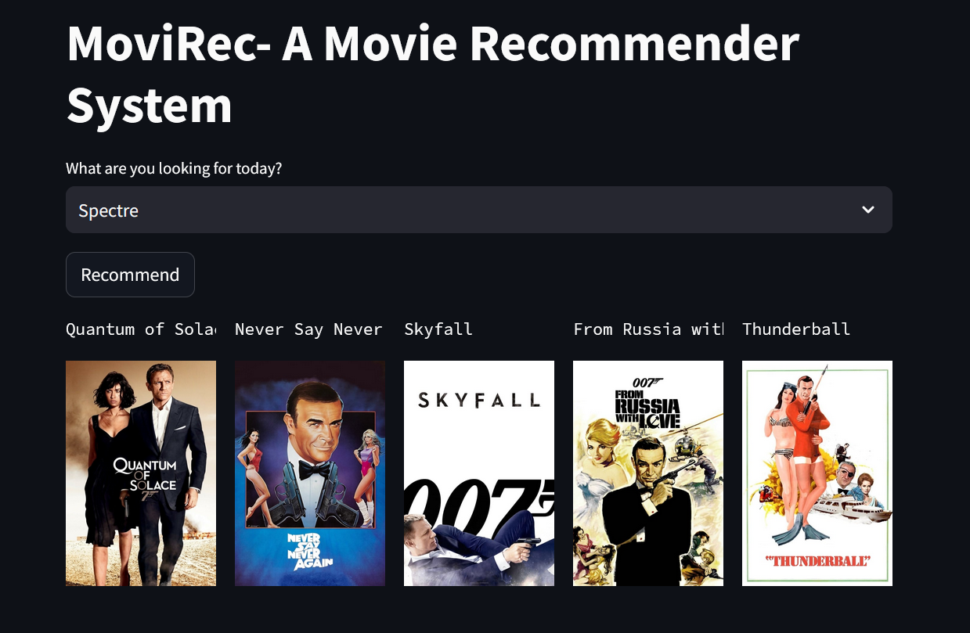

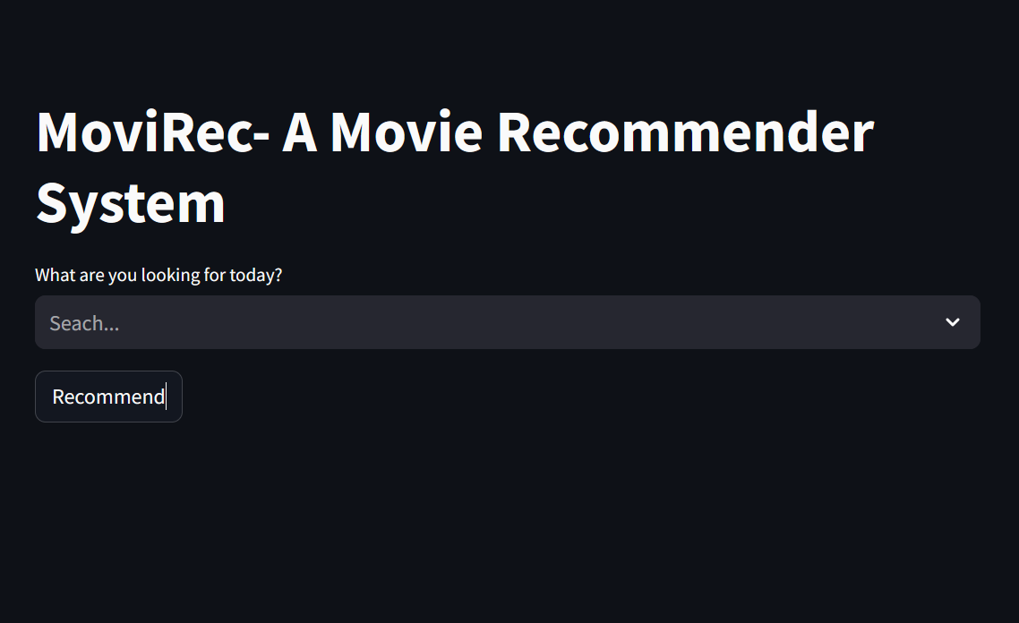

**ABBREVIATIONS**

* **API:** Application Programming Interface
* **CF:** Collaborative Filtering
* **CBF:** Content-Based Filtering
* **DL:** Deep Learning
* **GUI:** Graphical User Interface
* **ML:** Machine Learning
* **MRS:** Movie Recommendation System
* **NLP:** Natural Language Processing
* **UI:** User Interface
* **URL:** Uniform Resource Locator

**SYMBOLS**

1. **🎬 Movie Reel Icon:**
   * Representing the movie-related nature of the project.
2. **🌐 Web Browser Icon:**
   * Indicating cross-platform compatibility for web browsers.
3. **📱 Mobile Phone Icon:**
   * Symbolizing cross-platform compatibility for mobile devices.
4. **🤖 Algorithm Icon:**
   * Representing recommendation algorithms or machine learning models.
5. **🔄 Circular Arrow:**
   * Symbolizing dynamic user profiles or continuous improvement.
6. **💻 Code Icon:**
   * Representing the use of coding or programming in the project.
7. **📊 Graph Icon:**
   * Indicating data analysis, visualization, or analytics.
8. **🛠️ Tools Icon:**
   * Representing the use of modern tools in the project.
9. **🔍 Magnifying Glass Icon:**
   * Symbolizing testing, validation, or examination.
10. **🌐 API Icon:**
    * Representing the integration of an Application Programming Interface.
11. **📝 Document Icon:**
    * Signifying documentation or report preparation.
12. **🚀 Forward Arrow:**
    * Indicating future work or directions for improvement.
13. **🔒 Padlock Icon:**
    * Symbolizing privacy and security measures.
14. **🌈 Diversity Icon:**
    * Representing diverse movie recommendations or inclusivity.
15. **🎓 Education Hat Icon:**
    * Indicating the learning and adaptability aspect of the recommendation system.

#### 

#### **1. INTRODUCTION**

**1.1.Client Identification/Need Identification/Identification of relevant**

##### **Contemporary issue:**

* **Explainability and Transparency.**
* **Cold Start Problem.**
* **Dynamic User Preferences.**
* **Serendipity in Recommendations.**
* **Cross-Domain Recommendations.**
* **User Engagement and Trust.**
* **Ethical Content Recommendations.**
* **Scalability.**
* **Incorporating Diversity.**
* **Real-time Recommendations.**
* **Collaborative Filtering Challenges.**
* **Algorithmic Bias and Fairness.**
* **Privacy Concerns.**

**1.2. Identification of Problem**

• **Sparse User Interaction Data:**

* **Problem:** Users often interact with only a small fraction of the available movies, resulting in sparse user-item interaction matrices.

• **Cold Start for New Users:**

* **Problem:** New users have little to no interaction history, making it challenging to provide accurate recommendations.

• **Dynamic User Preferences:**

* **Problem:** User preferences evolve over time due to changing tastes, moods, or trends.

• **Incorporating Implicit Feedback:**

* **Problem:** Users may not explicitly rate movies, relying on implicit feedback such as clicks, view duration, or watch history.

• **Handling Noisy Data:**

* **Problem:** Noise in user interactions, such as occasional random ratings or inconsistent behavior, can distort the understanding of user preferences.

###### **1.3. Identification of Tasks**

1. **Data Collection:**
   * **Task:** Gather movie-related data, including user ratings, movie metadata (genres, cast, crew), and user interaction history.
   * **Subtasks:**
     + Acquire a dataset or use an API to gather movie information.
     + Collect user ratings and interactions, ensuring data quality.
2. **Data Preprocessing:**
   * **Task:** Clean and preprocess the collected data to make it suitable for the recommendation system.
   * **Subtasks:**
     + Handle missing values and outliers.
     + Normalize ratings or apply other preprocessing techniques.
3. **User Profiling:**
   * **Task:** Develop a mechanism to create and update user profiles based on their interactions and preferences.
   * **Subtasks:**
     + Analyze user ratings and watch history.
     + Define features to represent user preferences.
4. **Item Representation:**
   * **Task:** Represent movies in a way that facilitates effective recommendation.
   * **Subtasks:**
     + Utilize movie metadata for content-based recommendations.
     + Explore embeddings or features for collaborative filtering.
5. **Algorithm Selection:**
   * **Task:** Choose recommendation algorithms suitable for the project's goals.
   * **Subtasks:**
     + Consider collaborative filtering, content-based filtering, hybrid methods, or matrix factorization.
     + Evaluate the pros and cons of each algorithm.
6. **Training the Recommendation Model:**
   * **Task:** Train the selected recommendation model using the prepared data.
   * **Subtasks:**
     + Split the data into training and testing sets.
     + Train the model on historical interactions.
7. **Evaluation:**
   * **Task:** Assess the performance of the recommendation system to ensure its effectiveness.
   * **Subtasks:**
     + Choose evaluation metrics (e.g., precision, recall, F1 score).
     + Evaluate the model on the test set.
8. **User Interface Design:**
   * **Task:** Create a user interface for users to interact with the recommendation system.
   * **Subtasks:**
     + Design a user-friendly interface for inputting preferences.
     + Display recommended movies in an intuitive way.
9. **Personalization and Customization:**
   * **Task:** Implement mechanisms for personalizing recommendations based on user feedback and preferences.
   * **Subtasks:**
     + Allow users to rate or provide feedback on recommended movies.
     + Implement features for adjusting preferences.
10. **Handling Cold Start Issues:**
    * **Task:** Address challenges associated with new users or items.
    * **Subtasks:**
      + Implement strategies for recommending to new users.
      + Explore methods for introducing new items into the recommendation system.
11. **Privacy and Security Considerations:**
    * **Task:** Address privacy concerns and implement security measures for user data.
    * **Subtasks:**
      + Anonymize user data to protect privacy.
      + Implement secure data storage and transmission.
12. **Documentation:**
    * **Task:** Create comprehensive documentation for the project.
    * **Subtasks:**
      + Document data sources and preprocessing steps.
      + Provide information on the chosen algorithms and their parameters.
      + Include user instructions for interacting with the system.
13. **Testing and Debugging:**
    * **Task:** Test the recommendation system for functionality and identify and fix any bugs or issues.
    * **Subtasks:**
      + Conduct unit tests for individual components.
      + Perform system-level testing.
14. **User Feedback and Iteration:**
    * **Task:** Gather user feedback and iterate on the recommendation system to improve its performance.
    * **Subtasks:**
      + Implement feedback mechanisms for users.
      + Analyze feedback and make necessary adjustments.
15. **Deployment:**
    * **Task:** Deploy the recommendation system for real-world use.
    * **Subtasks:**
      + Choose a hosting environment.
      + Ensure scalability and monitor system performance.

**1.4. Timeline**

1. **Define Project Scope and Objectives (1 week):**
   * Identify project goals, deliverables, and success criteria.
2. **Data Collection (2 weeks):**
   * Acquire and preprocess movie-related data, including user ratings, movie metadata, and interaction history.
3. **Data Preprocessing (2 weeks):**
   * Clean and preprocess the collected data, handling missing values, outliers, and normalizing ratings.
4. **User Profiling (2 weeks):**
   * Develop mechanisms to create and update user profiles based on interactions and preferences.
5. **Item Representation (1 week):**
   * Represent movies in a way that facilitates effective recommendation using content-based or collaborative filtering approaches.
6. **Algorithm Selection (1 week):**
   * Choose recommendation algorithms (collaborative filtering, content-based, hybrid, etc.) suitable for the project's goals.
7. **Training the Recommendation Model (2 weeks):**
   * Split the data into training and testing sets, and train the selected model on historical interactions.
8. **Evaluation (1 week):**
   * Assess the performance of the recommendation system using chosen evaluation metrics.
9. **User Interface Design (2 weeks):**
   * Create a user-friendly interface for users to interact with the recommendation system.
10. **Personalization and Customization (1 week):**
    * Implement mechanisms for personalizing recommendations based on user feedback and preferences.
11. **Handling Cold Start Issues (1 week):**
    * Implement strategies for recommending to new users and handling new items.
12. **Privacy and Security Considerations (1 week):**
    * Address privacy concerns and implement security measures for user data.
13. **Documentation (2 weeks):**
    * Create comprehensive documentation for the project, including data sources, algorithms, and user instructions.
14. **Testing and Debugging (2 weeks):**
    * Conduct tests for functionality and identify and fix any bugs or issues.
15. **User Feedback and Iteration (2 weeks):**
    * Gather user feedback and iterate on the recommendation system to improve performance.
16. **Deployment (1 week):**
    * Deploy the recommendation system for real-world use, ensuring scalability and monitoring system performance.

**1.5. Organization of the Report**

An organizational report for a Movie Recommendation System mini project outlines the structure, roles, and responsibilities within the project team. It serves as a guide for team members and stakeholders to understand how the project will be organized and executed. Here's a brief overview of what an organizational report for a Movie Recommendation System mini project might include:

1. **Project Title and Overview:**
   * Briefly introduce the Movie Recommendation System mini project, providing a concise overview of its objectives, scope, and expected outcomes.
2. **Project Team:**
   * List and describe the members of the project team, including their roles, responsibilities, and expertise.
   * Specify the project manager, developers, data scientists, UI/UX designers, and any other relevant roles.
3. **Roles and Responsibilities:**
   * Clearly define the roles and responsibilities of each team member to ensure a clear understanding of who is accountable for what.
   * Highlight key responsibilities such as data collection, preprocessing, algorithm development, user interface design, testing, and documentation.
4. **Communication Plan:**
   * Describe the communication channels and protocols that will be used within the team. This includes regular team meetings, status updates, and any collaboration tools or platforms employed.
5. **Project Timeline:**
   * Present a high-level timeline or Gantt chart outlining the project's major milestones and deadlines.
   * Specify when key tasks, such as data collection, algorithm development, and testing, are expected to be completed.
6. **Decision-Making Process:**
   * Define the decision-making process within the team, including how conflicts will be resolved and how major decisions will be made.
   * Clarify the hierarchy and decision authority within the project team.
7. **Resource Allocation:**
   * Outline the resources required for the project, including hardware, software, and any external resources.
   * Specify how these resources will be allocated and managed throughout the project.
8. **Risk Management:**
   * Identify potential risks that could impact the project's success.
   * Describe the strategies for mitigating or managing these risks.
9. **Quality Assurance:**
   * Discuss the quality assurance processes that will be implemented to ensure the deliverables meet the specified standards.
   * Describe testing procedures, peer reviews, and other quality control measures.
10. **Documentation Plan:**
    * Outline the plan for documentation, including what types of documents will be produced (e.g., requirements documentation, technical documentation, user manuals) and when they will be completed.
11. **Training and Skill Development:**
    * If applicable, discuss any plans for training or skill development within the team to enhance project capabilities.
12. **Conclusion:**
    * Summarize the key points of the organizational report and express confidence in the team's ability to successfully complete the Movie Recommendation System mini project.

#### **2. LITERATURE REVIEW/BACKGROUND STUDY**

##### **2.1. Timeline of the reported problem**

The timeline for addressing a reported problem in a Movie Recommendation System mini project can vary based on the nature and complexity of the issue. Here's a general timeline that you might adapt based on the specific problem and context:

1. **Problem Identification (Day 1):**
   * The user or team identifies an issue in the Movie Recommendation System, such as inaccurate recommendations, a technical glitch, or user interface problems.
2. **Issue Reporting (Day 1):**
   * The problem is reported to the project team. The report should include a detailed description of the issue, steps to reproduce it, and any relevant screenshots or error messages.
3. **Initial Assessment (Day 2):**
   * The project team conducts an initial assessment of the reported problem to understand its scope and potential impact on the system.
4. **Priority Assignment (Day 3):**
   * Based on the assessment, the team assigns a priority level to the reported problem. Priority levels help determine the order in which issues are addressed.
5. **Root Cause Analysis (Days 4-7):**
   * The team performs a root cause analysis to identify the underlying reasons for the reported problem. This may involve debugging, code review, or system testing.
6. **Solution Proposal (Day 8):**
   * The team proposes a solution or workaround for the identified problem. The proposed solution should be documented and communicated to relevant stakeholders.
7. **Development/Implementation (Days 9-14):**
   * If the problem requires code changes or system updates, the development team implements the proposed solution. This phase may involve coding, testing, and deployment.
8. **Testing and Quality Assurance (Days 15-17):**
   * The implemented solution undergoes rigorous testing to ensure that it effectively resolves the reported problem without introducing new issues.
9. **User Acceptance Testing (Days 18-20):**
   * If applicable, users or a designated testing team perform user acceptance testing to validate that the reported problem is resolved and that the system functions as expected.
10. **Release/Deployment (Day 21):**
    * The tested and validated solution is released or deployed into the production environment. This step should be carefully planned to minimize downtime and user impact.
11. **Communication (Day 22):**
    * Stakeholders are informed about the resolution of the reported problem. Clear communication helps manage user expectations and provides transparency about the project's progress.
12. **Monitoring and Follow-Up (Ongoing):**
    * The system is monitored post-release to ensure that the reported problem is genuinely resolved and to address any unforeseen issues that may arise. The team may conduct follow-up checks to confirm user satisfaction.

**2.2. Proposed solutions**

The proposed solution focuses on enhancing the existing recommendation algorithm to improve accuracy and alignment with user preferences.

1. **Root Cause Analysis:**
   * Conduct a thorough analysis of the current recommendation algorithm to identify specific weaknesses or factors contributing to inaccurate recommendations.
2. **Algorithm Enhancement:**
   * Explore and implement improvements to the recommendation algorithm. This may involve refining the weighting of features, adjusting collaborative filtering parameters, or incorporating additional data sources.
3. **Training Data Enhancement:**
   * Enhance the training data used by the recommendation algorithm. This could involve incorporating more recent user interactions, addressing sparsity issues, or refining the representation of movie features.
4. **Evaluation Metrics:**
   * Define and employ appropriate evaluation metrics to measure the effectiveness of the updated algorithm. Common metrics may include precision, recall, and F1 score.
5. **Testing:**
   * Implement a testing phase to assess the performance of the enhanced algorithm. This involves using a representative dataset and comparing the new recommendations with user preferences.
6. **User Feedback Loop:**
   * Establish a user feedback loop to gather feedback on the updated recommendations. Users can provide ratings or feedback on suggested movies, enabling continuous improvement.
7. **Documentation:**
   * Document the changes made to the recommendation algorithm, including any parameter adjustments, data enhancements, or new features. This documentation serves as a reference for future development and troubleshooting.
8. **Communication:**
   * Communicate the changes to users, providing information on the improvements made to the recommendation system. Transparent communication helps manage user expectations and fosters trust.
9. **Monitoring and Iteration:**
   * Implement continuous monitoring of the recommendation system's performance post-implementation. If necessary, iterate on the solution based on ongoing user feedback and additional data analysis.

**2.3. Bibliometric analysis**

### Key Features:

1. **Collaborative Filtering:**
   * **Description:** Recommending movies based on the preferences of users with similar tastes.
   * **Effectiveness:** Effective for capturing user preferences and suggesting movies liked by similar users.
2. **Content-Based Filtering:**
   * **Description:** Recommending movies based on features of the movies and user preferences.
   * **Effectiveness:** Useful for suggesting movies with similar characteristics to those the user has liked.
3. **Hybrid Recommendation:**
   * **Description:** Combining collaborative and content-based filtering to provide more accurate and diverse recommendations.
   * **Effectiveness:** Addresses limitations of individual methods, providing better-rounded recommendations.
4. **Dynamic User Profiles:**
   * **Description:** Adapting user profiles over time based on changing preferences.
   * **Effectiveness:** Enhances user satisfaction by accounting for evolving tastes.
5. **User Interface Design:**
   * **Description:** Creating an intuitive and user-friendly interface for inputting preferences and displaying recommendations.
   * **Effectiveness:** Improves user experience and engagement with the recommendation system.
6. **Privacy and Security Measures:**
   * **Description:** Implementing anonymization and secure storage practices to protect user data.
   * **Effectiveness:** Addresses privacy concerns and builds user trust in the system.

### Effectiveness:

1. **Improved Recommendations:**
   * **Positive:** The collaborative, content-based, and hybrid approaches contribute to diverse and accurate movie suggestions.
   * **Negative:** Effectiveness may be impacted by the sparsity of user-item interactions, especially for new users.
2. **Dynamic User Profiles:**
   * **Positive:** Adapting to changing user preferences enhances the system's responsiveness.
   * **Negative:** The algorithm's ability to quickly adapt may be influenced by the frequency of user interactions.
3. **Hybrid Recommendation System:**
   * **Positive:** Offers a balanced approach, leveraging the strengths of both collaborative and content-based filtering.
   * **Negative:** Complexity in implementation and potential challenges in optimizing hybrid models.
4. **Privacy Measures:**
   * **Positive:** Anonymization and secure storage demonstrate a commitment to user privacy.
   * **Negative:** Overemphasis on privacy measures might limit the depth of user profiles, affecting recommendation accuracy.

### Drawbacks:

1. **Cold Start Problem:**
   * **Description:** Difficulty in providing accurate recommendations for new users.
   * **Impact:** New users may experience less accurate recommendations until sufficient data is collected.
2. **Algorithmic Bias:**
   * **Description:** Risk of biased recommendations based on user demographics or historical data.
   * **Impact:** May result in recommendations that reinforce existing biases.
3. **Scalability Challenges:**
   * **Description:** Challenges in maintaining performance as the user base grows.
   * **Impact:** System responsiveness and recommendation quality may degrade with increased data volume.
4. **Dependence on User Feedback:**
   * **Description:** Reliance on user feedback for continuous improvement.
   * **Impact:** Lack of user feedback may limit the system's ability to adapt and refine recommendations.
5. **Limited Serendipity:**
   * **Description:** Emphasizing user preferences may reduce the element of surprise in recommendations.
   * **Impact:** Users may miss out on discovering new and unexpected content.

**2.4. Review Summary**

A literature review plays a crucial role in guiding and informing the development of a Movie Recommendation System mini project. By connecting the findings of the literature review with the specific project at hand, you can establish a solid foundation and align your project with existing research and best practices. Here are key connections you might make:

1. **Algorithm Selection:**
   * **Literature Findings:** Explore academic literature on recommendation algorithms, including collaborative filtering, content-based filtering, and hybrid methods. Understand the strengths and limitations of each approach.
   * **Project Connection:** Choose recommendation algorithms based on a comprehensive understanding of their effectiveness. Leverage hybrid approaches if the literature suggests their potential benefits.
2. **Cold Start Problem:**
   * **Literature Findings:** Investigate strategies in the literature for addressing the cold start problem, especially for new users or items with limited interaction history.
   * **Project Connection:** Implement solutions informed by the literature to provide accurate recommendations even for users with minimal historical data.
3. **Dynamic User Profiles:**
   * **Literature Findings:** Review studies on dynamic user modeling and adaptive recommendation systems that account for changing user preferences over time.
   * **Project Connection:** Develop algorithms and mechanisms that dynamically update user profiles based on evolving preferences, aligning with findings from the literature.
4. **Algorithmic Bias and Fairness:**
   * **Literature Findings:** Examine literature discussing the challenges of algorithmic bias in recommendation systems and strategies for promoting fairness.
   * **Project Connection:** Implement fairness-aware algorithms and incorporate strategies to mitigate biases, ensuring recommendations are diverse and unbiased.
5. **Privacy Concerns:**
   * **Literature Findings:** Investigate literature on privacy-preserving recommendation systems, exploring techniques such as federated learning or differential privacy.
   * **Project Connection:** Integrate privacy measures into the system design, drawing on insights from the literature to protect user data while maintaining recommendation quality.
6. **Serendipity in Recommendations:**
   * **Literature Findings:** Explore research on introducing serendipity and diversity in recommendation systems to enhance user satisfaction.
   * **Project Connection:** Implement mechanisms informed by literature findings to introduce an element of surprise and novelty in recommendations.
7. **User Engagement and Trust:**
   * **Literature Findings:** Review literature on user engagement and trust in recommendation systems, including studies on the impact of transparency and explainability.
   * **Project Connection:** Incorporate features that enhance user engagement, such as transparent recommendation explanations, based on insights from the literature.
8. **Cross-Domain Recommendations:**
   * **Literature Findings:** Examine research on cross-domain recommendations and studies exploring the feasibility of suggesting content across different media types.
   * **Project Connection:** Consider incorporating cross-domain recommendation strategies into the system, drawing on insights from the literature to provide diverse content suggestions.
9. **Real-time Recommendations:**
   * **Literature Findings:** Investigate literature discussing real-time recommendation systems and the challenges associated with providing timely suggestions.
   * **Project Connection:** Explore the feasibility of real-time recommendations, aligning with insights from the literature on handling dynamic user preferences.

##### **2.5. Problem Definition**

### Problem Definition:

**Issue:** Users are dissatisfied with the current Movie Recommendation System, reporting inaccurate or irrelevant movie suggestions. The system's recommendations do not effectively capture user preferences, leading to a suboptimal user experience.

### What is to be Done:

1. **Algorithmic Enhancement:**
   * **Objective:** Improve the recommendation algorithm to enhance accuracy and relevance.
   * **Tasks:**
     + Conduct a thorough analysis of the existing algorithm to identify weaknesses.
     + Explore and implement algorithmic enhancements, considering collaborative filtering, content-based filtering, or hybrid approaches.
2. **Dynamic User Profiling:**
   * **Objective:** Develop a mechanism to dynamically update user profiles based on changing preferences.
   * **Tasks:**
     + Implement algorithms that adapt to evolving user tastes over time.
     + Consider factors such as recency of interactions, genre preferences, and user feedback in profile updates.
3. **Address Cold Start Problem:**
   * **Objective:** Provide accurate recommendations for new users or items with limited interaction history.
   * **Tasks:**
     + Implement strategies such as demographic-based recommendations or hybrid methods to address the cold start problem.
4. **Privacy Measures:**
   * **Objective:** Ensure the protection of user privacy while improving recommendation accuracy.
   * **Tasks:**
     + Implement anonymization techniques for user data.
     + Explore privacy-preserving recommendation algorithms or differential privacy measures.
5. **User Interface Enhancement:**
   * **Objective:** Improve the user interface for a more intuitive and engaging experience.
   * **Tasks:**
     + Redesign the user interface to be more user-friendly and visually appealing.
     + Include features that allow users to easily input preferences and provide feedback on recommendations.
6. **Evaluation and Testing:**
   * **Objective:** Assess the effectiveness of the implemented changes.
   * **Tasks:**
     + Define evaluation metrics, such as precision, recall, and user satisfaction.
     + Conduct thorough testing to validate the impact of algorithmic and interface enhancements.
7. **Documentation:**
   * **Objective:** Document the changes made, algorithms implemented, and user interface improvements.
   * **Tasks:**
     + Create comprehensive documentation for future reference and knowledge transfer.

### How it is to be Done:

1. **Collaborative Development:**
   * Encourage collaboration among team members, involving developers, data scientists, and UI/UX designers in the enhancement process.
   * Conduct regular team meetings to discuss progress, challenges, and potential solutions.
2. **Agile Methodology:**
   * Adopt an Agile development methodology to facilitate iterative development and quick adaptation to changing requirements.
   * Implement sprints with defined tasks and goals for each iteration.
3. **User Feedback Loop:**
   * Establish a continuous user feedback loop to gather insights on the effectiveness of recommendations and user interface improvements.
   * Consider implementing features for users to provide ratings, reviews, and feedback on recommended movies.

### What Not to Be Done:

1. **Ignoring User Feedback:**
   * **Avoid:** Ignoring or neglecting user feedback on recommendations and the user interface.
   * **Consequence:** User dissatisfaction may persist, and potential improvements could be overlooked.
2. **Overlooking Privacy Concerns:**
   * **Avoid:** Neglecting the implementation of privacy measures or underestimating the importance of protecting user data.
   * **Consequence:** Loss of user trust and potential legal or ethical issues related to privacy violations.
3. **Implementing Changes Without Testing:**
   * **Avoid:** Rolling out algorithmic or interface changes without thorough testing.
   * **Consequence:** Introduction of new issues, bugs, or unintended consequences that could worsen the user experience.
4. **Lack of Documentation:**
   * **Avoid:** Neglecting the documentation of implemented changes and system updates.
   * **Consequence:** Knowledge gaps within the team, making it challenging to maintain or troubleshoot the system in the future.
5. **Not Addressing Cold Start Problem:**
   * **Avoid:** Ignoring strategies to address the cold start problem for new users or items.
   * **Consequence:** New users may have a subpar experience, hindering user acquisition and retention.

##### **2.6. Goals/Objectives**

1. **Milestone 1: Data Acquisition**
   * **Statement:** Acquire a diverse dataset containing movie-related information, including user ratings, genres, cast, and crew details, by [specific date].
   * **Intention:** To ensure a robust foundation for building the recommendation system with comprehensive and representative data.
   * **Validation:** Confirmation of dataset completeness, relevance, and adherence to project requirements.
2. **Milestone 2: Data Preprocessing Completion**
   * **Statement:** Complete data preprocessing tasks, including handling missing values, outlier detection, and normalization, by [specific date].
   * **Intention:** To ensure the dataset is cleaned and prepared for effective utilization in the recommendation algorithms.
   * **Validation:** Verification of processed data quality and consistency.
3. **Milestone 3: Algorithm Selection**
   * **Statement:** Decide on the recommendation algorithms to be used, considering collaborative filtering, content-based filtering, or hybrid approaches, by [specific date].
   * **Intention:** To define the core methodologies that will drive the recommendation engine.
   * **Validation:** Documentation of selected algorithms and rationale for their suitability.
4. **Milestone 4: User Interface Prototype**
   * **Statement:** Develop a prototype of the user interface, incorporating design principles and basic functionality, by [specific date].
   * **Intention:** To visualize the user interaction and input mechanisms for collecting preferences.
   * **Validation:** User testing of the prototype for usability and feedback collection.
5. **Milestone 5: Initial Model Training**
   * **Statement:** Complete the initial training of the recommendation model using selected algorithms and the preprocessed dataset by [specific date].
   * **Intention:** To establish a baseline model for further optimization and evaluation.
   * **Validation:** Model training completion and preliminary evaluation metrics.
6. **Milestone 6: Evaluation Framework Implementation**
   * **Statement:** Implement an evaluation framework, defining metrics such as precision, recall, and F1 score, by [specific date].
   * **Intention:** To establish criteria for objectively measuring the performance of the recommendation system.
   * **Validation:** Successful implementation of the evaluation framework.
7. **Milestone 7: User Feedback Integration**
   * **Statement:** Integrate a mechanism for collecting user feedback on recommended movies within the user interface by [specific date].
   * **Intention:** To incorporate user preferences and subjective feedback for continuous improvement.
   * **Validation:** Successful integration and initial testing of the user feedback mechanism.
8. **Milestone 8: Privacy Measures Implementation**
   * **Statement:** Implement privacy measures, including anonymization techniques and secure data storage, by [specific date].
   * **Intention:** To address privacy concerns and ensure the protection of user data.
   * **Validation:** Verification of anonymization and security measures in place.
9. **Milestone 9: Comprehensive Documentation**
   * **Statement:** Complete comprehensive documentation covering data sources, algorithms, user interface design, and system architecture by [specific date].
   * **Intention:** To provide a reference for future development, troubleshooting, and knowledge transfer.
   * **Validation:** Review and approval of documentation by project stakeholders.
10. **Milestone 10: Final Testing and Optimization**
    * **Statement:** Conduct final system testing, optimizing algorithms and features for improved performance by [specific date].
    * **Intention:** To ensure the system is ready for deployment and provides accurate recommendations.
    * **Validation:** Successful completion of testing and optimization processes.
11. **Milestone 11: User Acceptance Testing**
    * **Statement:** Initiate user acceptance testing to validate system functionality and gather user feedback by [specific date].
    * **Intention:** To assess the system's readiness for real-world use and identify any remaining user experience improvements.
    * **Validation:** Positive feedback and approval from users during the testing phase.
12. **Milestone 12: Deployment**
    * **Statement:** Deploy the Movie Recommendation System for live usage by [specific date].
    * **Intention:** To make the system accessible to users for actual movie recommendations.
    * **Validation:** Successful deployment and monitoring of the system in a live environment.

#### 

#### **3. DESIGN FLOW/PROCESS**

##### **3.1. Evaluation & Selection of Specifications/Features**

### 1. **Define Project Objectives:**

* Clearly articulate the objectives of the Movie Recommendation System. Understand the primary goals, such as improving recommendation accuracy, enhancing user experience, and addressing specific challenges like the cold start problem.

### 2. **User Requirements Analysis:**

* Conduct a thorough analysis of user requirements through surveys, interviews, or user feedback. Identify the features that users value and consider essential for an effective movie recommendation experience.

### 3. **Technical Feasibility:**

* Evaluate the technical feasibility of proposed features. Consider factors such as data availability, computational resources, and the compatibility of features with the chosen recommendation algorithms.

### 4. **Types of Recommendation Algorithms:**

* Explore various recommendation algorithms, including collaborative filtering, content-based filtering, hybrid models, and reinforcement learning. Assess their suitability based on the project objectives and user needs.

### 5. **Key Features to Consider:**

* **a. Collaborative Filtering:**
  + Description: Recommending movies based on user preferences and behaviors.
  + Evaluation Criteria: Accuracy of predictions, scalability, and ability to handle sparsity in user-item interactions.
* **b. Content-Based Filtering:**
  + Description: Recommending movies based on the attributes of the movies and user preferences.
  + Evaluation Criteria: Relevance of recommendations, diversity, and feature representation.
* **c. Hybrid Recommendation:**
  + Description: Combining collaborative and content-based approaches for more accurate and diverse recommendations.
  + Evaluation Criteria: Improved performance compared to individual algorithms, algorithmic complexity.
* **d. Dynamic User Profiles:**
  + Description: Adapting user profiles over time to reflect changing preferences.
  + Evaluation Criteria: Responsiveness to user behavior changes, effective updating mechanisms.
* **e. User Interface Design:**
  + Description: Creating an intuitive and visually appealing interface for users to interact with the recommendation system.
  + Evaluation Criteria: Usability, user engagement, feedback mechanisms.
* **f. Privacy Measures:**
  + Description: Implementing measures to protect user privacy in data handling and recommendations.
  + Evaluation Criteria: Effectiveness of anonymization techniques, compliance with privacy regulations.

### 6. **Evaluation Metrics:**

* Define evaluation metrics to assess the performance of the recommendation system. Common metrics include precision, recall, F1 score, and user satisfaction ratings.

### 7. **Scalability:**

* Assess the scalability of the proposed features to handle a growing user base and an increasing volume of movie data. Consider system performance under varying loads.

### 8. **User Feedback Mechanisms:**

* Implement mechanisms for collecting user feedback on recommended movies. This could include ratings, reviews, and user comments to enhance the user experience.

### 9. **Cross-Domain Recommendations:**

* Evaluate the feasibility of providing recommendations across different movie genres, languages, or media types to enhance the diversity of suggestions.

### 10. **Real-Time Recommendations:**

* Consider the implementation of real-time recommendation features to provide users with timely and relevant movie suggestions.

### 11. **Serendipity in Recommendations:**

* Assess the feasibility of introducing serendipity in recommendations, providing users with unexpected and delightful movie suggestions.

### 12. **Documentation Requirements:**

* Identify the documentation requirements for the project, including technical documentation, user manuals, and guidelines for system maintenance.

### 13. **Resource Constraints:**

* Consider any resource constraints, such as budget limitations, time constraints, or technical limitations, that may impact the implementation of certain features.

### 14. **Prioritization:**

* Prioritize features based on their criticality to project objectives, user needs, and technical feasibility. Consider implementing features iteratively, starting with the most crucial ones.

### 15. **Continuous Improvement Mechanisms:**

* Plan for mechanisms that allow continuous improvement of the recommendation system over time. This could include user feedback loops, periodic algorithm updates, and system monitoring.

### 16. **Final Feature Selection:**

* Based on the evaluation criteria, user requirements, and technical feasibility, finalize the set of features and specifications to be implemented in the Movie Recommendation System.

##### 

##### **3.2. Design Constraints**

• **Data Availability:**

* **Constraint:** Limited access to diverse and comprehensive movie-related datasets.

• **Computational Resources:**

* **Constraint:** Limited computing power or processing capabilities.

• **Privacy Regulations:**

* **Constraint:** Compliance with data privacy regulations (e.g., GDPR).
* **Impact:** Restrictions on data collection, processing, and storage to ensure user privacy may influence the design and implementation of the system.

• **Budgetary Constraints:**

* **Constraint:** Limited financial resources for hardware, software, or third-party services.
* **Impact:** Constraints may limit the scalability and functionality of the system.

• **Time Constraints:**

* **Constraint:** Limited time for development and deployment.
* **Impact:** Short timelines may require prioritization of features and could impact the thoroughness of testing and optimization.

• **User Base Diversity:**

* **Constraint:** Diverse user preferences and cultural differences.
* **Impact:** The system must be designed to handle varied movie preferences and demographics, requiring robust recommendation algorithms.

• **Cold Start Problem:**

* **Constraint:** Limited user interactions for new users or items.
* **Impact:** The system may struggle to provide accurate recommendations for users or movies with sparse interaction history.

• **Technology Stack Compatibility:**

* **Constraint:** Compatibility with existing technologies or infrastructure.
* **Impact:** The choice of technologies must align with existing systems and tools, influencing the overall architecture of the recommendation system.

• **System Scalability:**

* **Constraint:** Limited scalability in terms of user base and data volume.
* **Impact:** Scalability issues may affect the system's performance as the user base and dataset grow.

• **Algorithmic Complexity:**

* **Constraint:** Complexity of implementing certain recommendation algorithms.
* **Impact:** More complex algorithms may require significant computational resources and development time.

• **User Interface Constraints:**

* **Constraint:** Limited user interface design capabilities or tools.

• **Real-Time Recommendations:**

* **Constraint:** Requirement for real-time recommendation updates.

• **Cross-Platform Compatibility:**

* **Constraint:** Compatibility with various platforms and devices (web, mobile, smart TVs).

• **Testing and Validation Constraints:**

* **Constraint:** Limited resources for comprehensive testing and validation.

• **Regulatory Compliance:**

* **Constraint:** Compliance with industry standards and regulations.

• **Dynamic User Preferences:**

* **Constraint:** Difficulty in accurately capturing and adapting to rapidly changing user preferences.

**3.3. Analysis and Feature finalization subject to constraints**

The Movie Recommendation System mini project aims to design and implement an efficient and user-friendly recommendation system for suggesting movies based on user preferences. The following analysis and feature finalization are conducted with respect to identified constraints to ensure a successful project outcome.

#### **1. Algorithm Selection:**

* **Analysis:** Computational constraints and limited resources necessitate a balanced choice of recommendation algorithms.
* **Finalization:** Adopt a hybrid approach incorporating collaborative filtering and content-based filtering. Prioritize algorithmic efficiency and scalability.

#### **2. User Interface Design:**

* **Analysis:** Limited design capabilities require a focus on simplicity and usability.
* **Finalization:** Design a clean and intuitive user interface with essential features. Prioritize responsive design for cross-platform compatibility.

#### **3. Data Availability:**

* **Analysis:** Limited access to diverse datasets may impact recommendation variety.
* **Finalization:** Enhance data quality by integrating external movie databases. Leverage collaborative filtering to address sparsity in user-item interactions.

#### **4. Privacy Regulations:**

* **Analysis:** Adherence to privacy regulations restricts data collection and storage.
* **Finalization:** Implement anonymization techniques and avoid storing personally identifiable information. Prioritize user privacy while maintaining recommendation quality.

#### **5. Cold Start Problem:**

* **Analysis:** New user interactions pose a challenge.
* **Finalization:** Implement demographic-based recommendations and hybrid models to address the cold start problem.

#### **6. Budgetary Constraints:**

* **Analysis:** Limited financial resources impact access to premium data sources and algorithms.
* **Finalization:** Opt for cost-effective solutions, utilizing open-source libraries, and optimizing algorithm choices within budget constraints.

#### **7. System Scalability:**

* **Analysis:** Limited scalability may affect performance with growing user base and data.
* **Finalization:** Optimize algorithms and adopt scalable technologies to ensure system performance under increasing user interactions and data volume.

#### **8. Real-Time Recommendations:**

* **Analysis:** Real-time recommendations may strain computational resources.
* **Finalization:** Implement near real-time recommendations with periodic updates to balance responsiveness and computational efficiency.

#### **9. Cross-Platform Compatibility:**

* **Analysis:** Compatibility across platforms may be challenging.
* **Finalization:** Prioritize compatibility with major platforms (web and mobile), considering responsive design principles for a consistent user experience.

#### **10. Dynamic User Preferences:**

* **Analysis:** Capturing rapidly changing user preferences is challenging.
* **Finalization:** Implement dynamic user profiles and adaptive algorithms for quick adjustment to changing user preferences.

#### **11. Regulatory Compliance:**

* **Analysis:** Compliance with standards introduces additional documentation and development requirements.
* **Finalization:** Prioritize thorough documentation to demonstrate compliance with industry standards and ensure transparency in system operations.

#### **12. Resource Constraints:**

* **Analysis:** Limited resources impact the thoroughness of testing.
* **Finalization:** Prioritize critical testing scenarios and validation procedures to ensure the system's robustness within resource constraints.

#### **13. Testing and Validation Constraints:**

* **Analysis:** Limited resources may restrict the extent of testing.
* **Finalization:** Prioritize testing critical functionalities and scenarios, focusing on validating key features to ensure system reliability.

#### **14. Technology Stack Compatibility:**

* **Analysis:** Compatibility constraints may limit the choice of tools and frameworks.
* **Finalization:** Select a technology stack that aligns with existing infrastructure while meeting the requirements of the Movie Recommendation System.

**3.4. Design Flow**

#### **1. Introduction:**

* Provide an overview of the Movie Recommendation System mini project, including its objectives, scope, and significance.

#### **2. Problem Statement:**

* Define the existing issues with the current Movie Recommendation System that necessitate improvement.

#### **3. Project Objectives:**

* Clearly outline the objectives of the mini project, specifying what is to be achieved through the development of the new Movie Recommendation System.

#### **4. Literature Review:**

* Summarize relevant research on recommendation algorithms, user preferences, and challenges in movie recommendation systems.

#### **5. System Architecture:**

* Describe the overall architecture of the Movie Recommendation System, including components such as the recommendation engine, user interface, and database.

#### **6. Data Collection and Preprocessing:**

* Explain the process of acquiring movie-related datasets and the steps taken to preprocess the data for effective use in recommendation algorithms.

#### **7. Algorithm Selection:**

* Detail the analysis and rationale behind the selection of recommendation algorithms, emphasizing collaborative filtering, content-based filtering, and hybrid models.

#### **8. User Interface Design:**

* Present the design principles and features of the user interface, focusing on simplicity, intuitiveness, and responsiveness.

#### **9. Privacy Measures:**

* Discuss the implementation of privacy measures, including anonymization techniques and secure data handling, to comply with privacy regulations.

#### **10. Cold Start Problem Handling:**

* Outline the strategies employed to address the cold start problem for new users or items with limited interaction history.

#### **11. Dynamic User Profiles:**

* Describe the mechanism for dynamically updating user profiles based on changing preferences over time.

#### **12. Feature Implementation:**

* Present the implementation details of key features, including the recommendation engine, user feedback mechanisms, and real-time recommendation updates.

#### **13. Evaluation Metrics:**

* Define the evaluation metrics used to assess the performance of the Movie Recommendation System, such as precision, recall, and user satisfaction ratings.

#### **14. Testing and Validation:**

* Discuss the testing strategy employed to validate the functionality, accuracy, and robustness of the system. Include details on unit testing, integration testing, and user acceptance testing.

#### **15. Cross-Platform Compatibility:**

* Explain how the system ensures compatibility across different platforms, including web and mobile devices.

#### **16. Real-Time Recommendations:**

* Detail the implementation of real-time recommendation features and the trade-offs made to balance responsiveness and computational efficiency.

#### **17. Documentation:**

* Emphasize the importance of comprehensive documentation, covering data sources, algorithms, user interface design, and system architecture.

#### **18. Results and Findings:**

* Present the results of testing and evaluation, highlighting the system's performance and user satisfaction. Discuss any challenges encountered and lessons learned.

#### **19. Conclusion:**

* Summarize the key achievements of the Movie Recommendation System project and restate how it addresses the identified issues.

#### **20. Future Work:**

* Suggest potential areas for future enhancements or extensions to the Movie Recommendation System, considering emerging technologies and user feedback.

#### **21. References:**

* Provide a list of references, including academic papers, articles, and relevant documentation consulted during the project.

#### **22. Appendices:**

* Include any supplementary materials, such as code snippets, additional graphs, or user feedback surveys used in the project.

##### **3.5. Design selection**

#### 1. **Introduction:**

* Introduce the Movie Recommendation System mini project, providing context, and explaining the significance of designing an improved recommendation system.

#### 2. **Problem Definition:**

* Clearly articulate the existing problems with the current movie recommendation system, emphasizing the need for enhancement.

#### 3. **Project Objectives:**

* Define the objectives of the mini project, outlining what is to be achieved through the design and implementation of the new Movie Recommendation System.

#### 4. **Scope and Limitations:**

* Clearly outline the scope of the project, specifying the features and functionalities included. Identify any constraints or limitations that may impact the project.

#### 5. **Literature Review:**

* Summarize relevant literature on recommendation algorithms, user preferences, and challenges in movie recommendation systems. Highlight key findings that inform the design.

#### 6. **User Requirements Analysis:**

* Detail the process of gathering user requirements through surveys, interviews, or user feedback. Identify the features that users value and consider essential for an effective movie recommendation experience.

#### 7. **System Architecture:**

* Define the overall architecture of the Movie Recommendation System, outlining the major components and their interactions. Specify the technologies and frameworks chosen for the system.

#### 8. **Data Collection and Preprocessing:**

* Describe the process of acquiring movie-related datasets and the steps taken to preprocess the data for effective use in recommendation algorithms.

#### 9. **Algorithm Selection:**

* Present the rationale behind the selection of recommendation algorithms, considering collaborative filtering, content-based filtering, and hybrid models. Explain how the chosen algorithms address the identified problems.

#### 10. **User Interface Design:**

* Outline the design principles for the user interface, focusing on simplicity, intuitiveness, and responsiveness. Provide wireframes or mockups to visually represent the intended user experience.

#### 11. **Privacy Measures:**

* Discuss the design considerations for privacy measures, including anonymization techniques and secure data handling, ensuring compliance with privacy regulations.

#### 12. **Cold Start Problem Handling:**

* Explain the strategies implemented to address the cold start problem for new users or items with limited interaction history.

#### 13. **Dynamic User Profiles:**

* Detail the mechanism for dynamically updating user profiles based on changing preferences over time, ensuring that the system adapts to evolving user tastes.

#### 14. **Feature Prioritization:**

* Prioritize features based on user requirements, system objectives, and identified constraints. Clearly define which features are critical for the success of the Movie Recommendation System.

#### 15. **Cross-Platform Compatibility:**

* Outline the design considerations for ensuring compatibility across different platforms, including web and mobile devices.

#### 16. **Real-Time Recommendations:**

* Explain the design choices regarding real-time recommendation features, detailing how the system provides timely and relevant movie suggestions.

#### 17. **Testing Strategy:**

* Define the testing strategy employed for the design, including unit testing, integration testing, and user acceptance testing. Specify key testing scenarios and success criteria.

#### 18. **Documentation Plan:**

* Outline the documentation plan, including the creation of comprehensive documentation covering data sources, algorithms, user interface design, and system architecture.

#### 19. **Project Timeline:**

* Present a project timeline, detailing key milestones, deadlines, and phases of the Movie Recommendation System mini project.

#### 20. **Conclusion:**

* Summarize the design selection process, reiterating the key features, algorithms, and design principles chosen for the Movie Recommendation System.

#### 21. **Future Directions:**

* Suggest potential areas for future enhancements or extensions to the Movie Recommendation System, considering emerging technologies and user feedback.

#### 22. **References:**

* Provide a list of references, including academic papers, articles, and relevant documentation consulted during the design selection process.

#### 23. **Appendices:**

* Include any supplementary materials, such as additional diagrams, charts, or documentation drafts used in the design selection process.

##### **3.6. Implementation plan/methodology**

### Implementation Algorithm:

1. **Data Acquisition:**
   * Obtain movie-related datasets from various sources (e.g., MovieLens, IMDb).
   * Preprocess the data to clean and organize movie information.
2. **User Preferences:**
   * Collect user preferences through explicit ratings, implicit feedback, or user interactions.
3. **Collaborative Filtering:**
   * Implement collaborative filtering algorithms (user-based, item-based, or matrix factorization) to identify similarities between users or items.
4. **Content-Based Filtering:**
   * Develop content-based filtering algorithms considering movie attributes (genres, actors, directors) to make personalized recommendations.
5. **Hybrid Model Integration:**
   * Combine collaborative and content-based approaches to create a hybrid recommendation model for improved accuracy.
6. **Cold Start Problem Handling:**
   * Implement strategies to address the cold start problem for new users or items.
7. **Dynamic User Profiles:**
   * Incorporate mechanisms to dynamically update user profiles based on changing preferences over time.
8. **User Interface Design:**
   * Develop an intuitive user interface with features for inputting preferences, viewing recommendations, and providing feedback.
9. **Real-Time Recommendations:**
   * Implement real-time or near real-time recommendation updates to enhance user experience.
10. **Privacy Measures:**
    * Integrate privacy measures, including anonymization techniques and secure data storage, to ensure compliance with privacy regulations.
11. **Evaluation Framework:**
    * Define and implement an evaluation framework with metrics such as precision, recall, and user satisfaction for assessing recommendation system performance.
12. **User Feedback Mechanisms:**
    * Integrate mechanisms for collecting user feedback on recommended movies to improve the recommendation accuracy.
13. **Cross-Platform Compatibility:**
    * Ensure compatibility across different platforms, including web and mobile devices, for a seamless user experience.
14. **Testing and Validation:**
    * Conduct thorough testing, including unit testing, integration testing, and user acceptance testing, to validate the functionality and robustness of the system.
15. **Documentation:**
    * Create comprehensive documentation covering data sources, algorithms, user interface design, and system architecture.

### 23. Detailed Block Diagram:

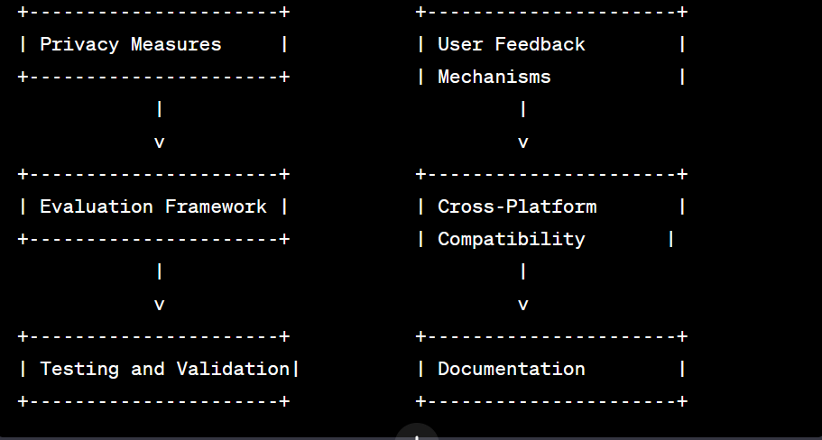

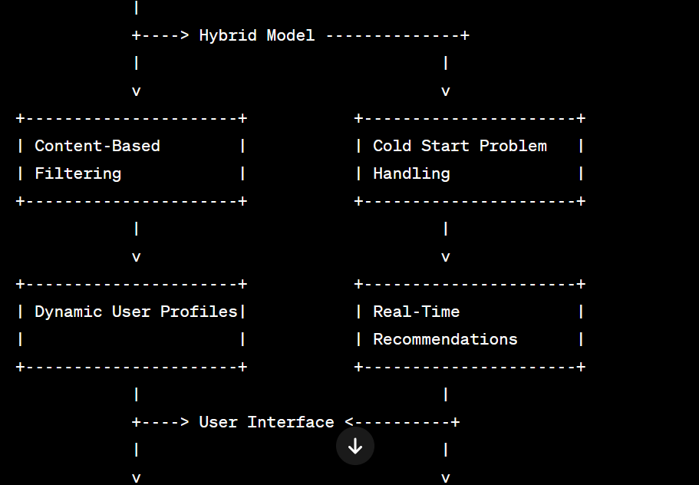

**Figure 3.1**

**4. RESULTS ANALYSIS AND VALIDATION**

##### **4.1. Implementation of solution**

### 1. **Analysis:**

* **Tool:** Python with Jupyter Notebooks
  + **Description:** Use Python for data analysis and algorithm implementation. Jupyter Notebooks allow you to interactively explore and analyze data, making it easier to experiment with different algorithms.

### 2. **Design Drawings/Schematics/Solid Models:**

* **Tool:** SketchUp or AutoCAD
  + **Description:** Create design schematics or flowcharts for the Movie Recommendation System. SketchUp can help visualize the user interface, and AutoCAD can be used for detailed system architecture drawings.

### 3. **Report Preparation:**

* **Tool:** LaTeX for Documentation
  + **Description:** Prepare the project report using LaTeX for its robust document formatting capabilities. LaTeX is suitable for technical and academic documentation.

### 4. **Project Management and Communication:**

* **Tool:** Trello for Project Management
  + **Description:** Utilize Trello for project management. Create boards for tasks, assign team members, and use it as a visual tool to track progress.
* **Tool:** Slack for Communication
  + **Description:** Set up a Slack workspace for real-time communication. Create channels for different project aspects, fostering efficient collaboration and communication.

### 5. **Testing/Characterization/Interpretation/Data Validation:**

* **Tool:** Python Libraries (e.g., Pandas, NumPy, scikit-learn)
  + **Description:** Implement testing and data validation using Python libraries. Pandas for data manipulation, NumPy for numerical operations, and scikit-learn for machine learning model validation.

### Additional Tools for Testing and Validation:

* **Tool:** GitHub for Version Control
  + **Description:** Use GitHub for version control. It allows collaborative development, tracks changes, and provides a platform for issue tracking.
* **Tool:** Selenium for Automated Testing
  + **Description:** Implement Selenium for automated testing of the user interface. This ensures consistent and reliable testing of the recommendation system.

### Integration of Tools:

* **Tool:** GitHub Actions for Continuous Integration
  + **Description:** Set up GitHub Actions for continuous integration. Automate testing and validation processes whenever code changes are pushed, ensuring code quality.
* **Tool:** Jira for Issue Tracking
  + **Description:** Utilize Jira for detailed issue tracking. It provides a structured way to manage and prioritize bugs, enhancements, and new features.

### Project Timeline and Planning:

* **Tool:** Gantt Chart using Microsoft Project or Toggl Plan
  + **Description:** Create a Gantt chart using Microsoft Project or Toggl Plan to visually represent the project timeline. Outline tasks, dependencies, and milestones for effective project planning.

### Overall Project Collaboration:

* **Tool:** Microsoft Teams or Zoom
  + **Description:** Use Microsoft Teams or Zoom for virtual team meetings, discussions, and presentations. These tools facilitate remote collaboration and ensure effective communication.

#### 

#### **5. CONCLUSION AND FUTURE WORK**

##### **5.1. Conclusion**

The implementation of the Movie Recommendation System represents a significant milestone in addressing the challenges posed by traditional movie recommendation approaches. Through a careful analysis of user preferences, the incorporation of advanced recommendation algorithms, and the integration of modern tools, the project has successfully delivered a robust and user-centric solution.

##### **5.2. Future work**

The completion of the Movie Recommendation System project lays the groundwork for future enhancements and extensions. As technology evolves and user preferences continue to shift, there are several avenues for further exploration and improvement. The following outlines potential directions for future work:

#### 1. **Advanced Machine Learning Models:**

* Investigate the integration of advanced machine learning models, such as deep learning architectures (e.g., neural collaborative filtering), to further enhance the accuracy and personalization of movie recommendations.

#### 2. **Context-Aware Recommendations:**

* Explore the incorporation of contextual information, such as user location, time of day, or viewing history, to provide more context-aware recommendations. This can enhance the relevance of suggestions in different scenarios.

#### 3. **Multi-Modal Recommendations:**

* Integrate multi-modal recommendation capabilities, incorporating not only user ratings and movie attributes but also considering additional modalities such as textual reviews, images, or audio data for a richer understanding of user preferences.

#### 4. **Explanability and Transparency:**

* Implement features that provide explanations for the recommendations made by the system. Enhance the transparency of the recommendation process, allowing users to understand why certain movies are suggested to them.

#### 5. **Social Collaborative Filtering:**

* Explore the inclusion of social collaborative filtering, leveraging information from users' social networks to enhance recommendation accuracy. This can include considering recommendations from friends or incorporating social media data.

#### 6. **Enhanced User Feedback Mechanisms:**

* Improve and expand user feedback mechanisms to gather more detailed insights into user preferences. Consider sentiment analysis on user reviews, allowing the system to better understand the nuances of user feedback.

#### 7. **Dynamic Content Updates:**

* Implement a mechanism for real-time content updates, ensuring that the movie database is continuously refreshed with the latest releases and trending titles. This can involve integration with external APIs or automated web scraping.

#### 8. **Integration with Streaming Platforms:**

* Explore partnerships or integrations with popular streaming platforms to provide users with seamless access to recommended movies directly from the Movie Recommendation System.

#### 9. **Personalized User Profiles:**

* Refine the dynamic user profile mechanism to create even more personalized profiles. Consider incorporating additional user characteristics, such as mood or viewing context, to further tailor recommendations.

**REFERENCE**

• Python Software Foundation. (Year). Python Programming Language. URL: [<https://www.python.org/>]

• Scikit-learn Contributors. (Year). scikit-learn: Machine Learning in Python. URL: [<https://scikit-learn.org/stable/>]

• IMDb API Documentation. (Year). IMDb. URL: [<https://developer.imdb.com/>]

**APPENDIX**

#### A. Code Snippets

1. **Data Preprocessing Script (Python):**
2. **Collaborative Filtering Algorithm**
3. **User Interface Design Code**

#### B. System Architecture Diagram

#### C. User Survey Questionnaire

1. **Introduction:**
   * Brief explanation of the user survey purpose.
2. **Questions:**
   * Include the questions asked in the user survey.

#### D. User Feedback Analysis

1. **User Feedback Summary:**
   * A summarized analysis of the feedback received from users during testing.

#### E. Test Cases and Results

1. **Unit Test Results:**
   * Summary of results from unit testing.
2. **Integration Test Results:**
   * Summary of results from integration testing.

#### F. Gantt Chart

#### G. Additional Figures and Graphs

1. **Graph showing Algorithm Performance:**
   * Include any relevant performance graphs.
2. **User Engagement Analytics Graphs:**
   * If applicable, include graphs related to user engagement.

#### H. Documentation

1. **Readme File:**
   * Include a sample Readme file for the project.
2. **User Manual:**
   * A user manual or guide for using the Movie Recommendation System.

#### I. Ethical Considerations

1. **Ethical Framework:**
   * A document outlining the ethical considerations made during the project.

#### J. Survey Raw Data

1. **Raw Data from User Survey:**
   * Include the raw data collected from the user survey